Troubleshooting missing sponsor credit in Insights Member Traffic Lights
Use this guide when a member expects sponsorship credit in BNI Insights Member Traffic Lights but the credit is missing or assigned to someone else.
Sponsor assignment initially comes from the person recorded as inviting the applicant on their most recently recorded visit. The sponsor named on the application is for reference and does not automatically set the membership sponsor. Insights Member Traffic Lights runs once monthly, so a later correction may not appear in the current results.

1 Check the current membership sponsor
Review the sponsored member’s membership record in BNI Connect. Confirm which person is currently recorded as the sponsor and compare that with the expected sponsor. If it is incorrect, arrange for an authorized administrator to correct it. Record the correction date if known.

2 Locate the visit used for the initial assignment
Go to OPERATIONS > REGION > MANAGE MEMBERSHIPS > ENTER NEW APPLICATION. Locate the applicant and review the records preceding the application, including the deleted VISIT record. A red asterisk identifies a deleted record.
Note the visit date and chapter. These details allow you to find the corresponding visitor event and identify who received the original invitation credit.
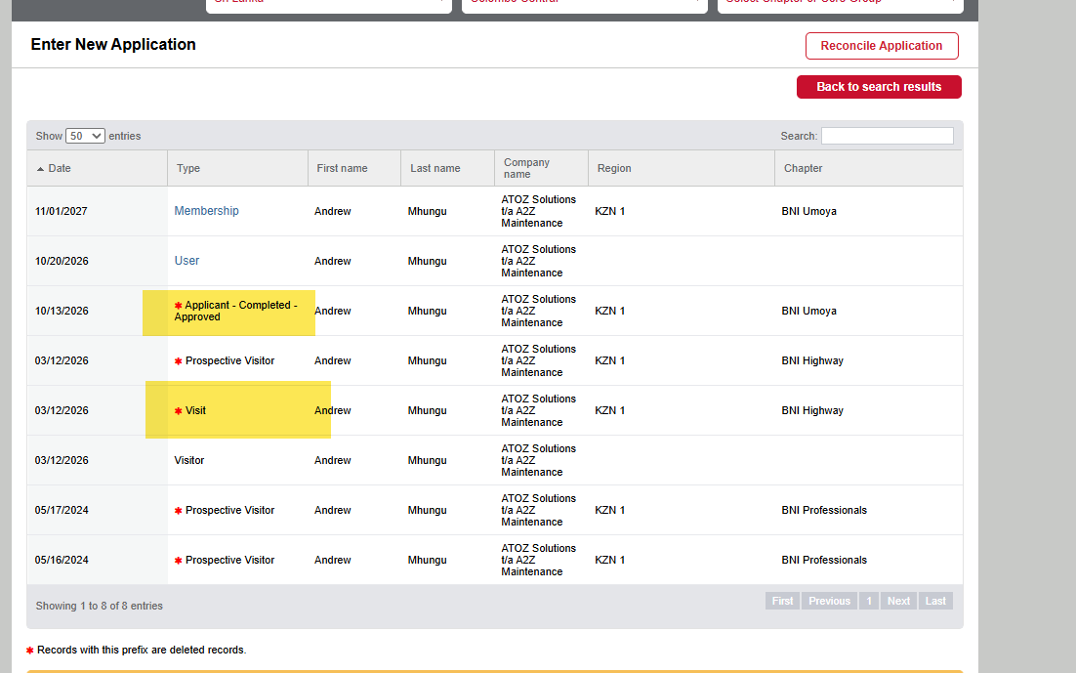
Example application history with the application and earlier VISIT record highlighted.

3 Confirm who was credited with the visit
Go to TOOLS > POWER SEARCH > FIND A SYSTEM EVENT. Search for the Visitor Entry event using the region, chapter and date range covering the visit identified in step 2. Match the visitor and check the Invited By column.
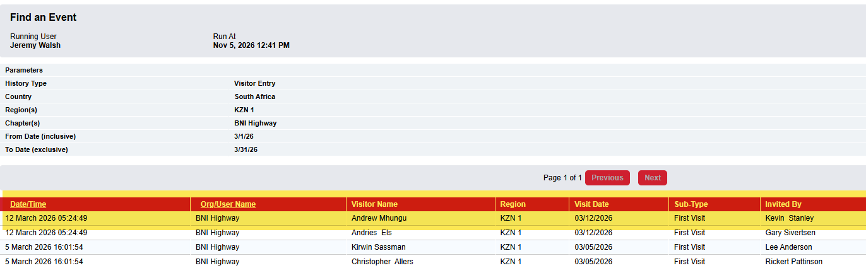
The example visitor event credits Kevin Stanley as the person who invited the applicant.

4 Compare the application for reference
Review the sponsor named by the applicant. This shows who the applicant considers their sponsor, but it does not automatically update the membership sponsor. A difference between this name and the visitor event helps explain the initial assignment.
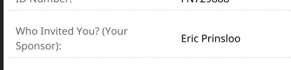
The example application names Eric Prinsloo, which differs from the visitor event.

5 Assess the monthly processing timing
If the membership record now shows the correct sponsor but the current Insights Member Traffic Lights results do not, a possible explanation is that the membership sponsor was corrected after the once monthly run. Check any available confirmation of when the correction was made and compare it with the relevant run.
There is no audit log for this sponsor change. Without separate evidence, describe a correction after the monthly run as a likely explanation only; do not state that the timing has been confirmed. Recheck after the next monthly run rather than expecting an immediate change. Do not promise that earlier results will be recalculated.

If the discrepancy remains
If the credit is still missing after the next monthly run, or the evidence does not fit this sequence, refer the case for further investigation. Include the sponsor and sponsored member names and IDs, chapter and region, visit and application dates, visitor event details, current membership sponsor, any known correction date, and the Insights period being reviewed.

