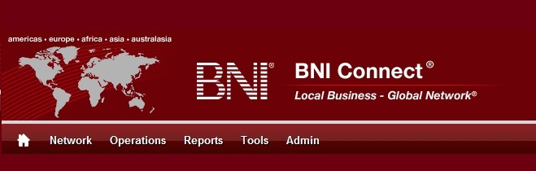

Get Connected – Stay Connected

  - BNI Connect Educational Moment #10
  - Join a Group
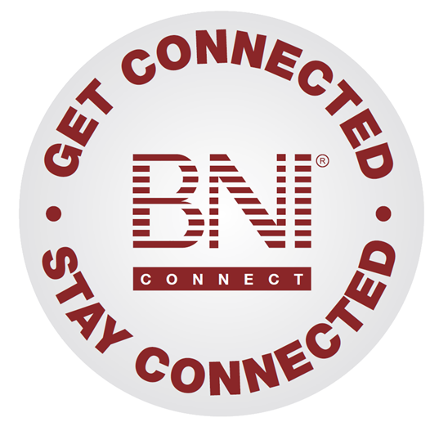
“Get Connected – Stay Connected” is a program to help you and your fellow chapter members learn more about BNI Connect in bite sized chunks throughout the year. To accompany the monthly emails sent to all members, here is an Educational Moment to help further enforce the message as well as to directly assist with a more descriptive lesson about the monthly topic.
Included in each Educational Moment are three resources for your presentation.
- A multimedia video. You can show this short 3-5 minute video if your chapter is equipped to present in this fashion. In addition, you are welcome to share the link to this video with your chapter members.
- A Step-By-Step visual guide. A link to the support document covering the topic will be included for those members that prefer to learn in a screenshot and text based fashion.
- Chapter Presentation. Ideas and things to say to present this topic to your chapter during the educational moment at a weekly BNI meeting.

Join a Group
BNI Connect 3 Minute Educational Moment Video
Link to video: http://youtu.be/mXxrC2kRlnE
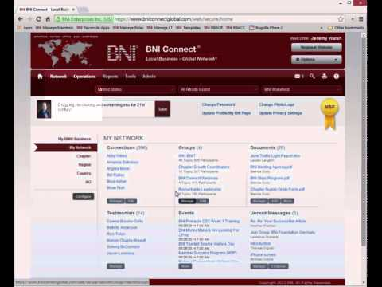

BNI Podcast
BNI Podcast Episode 363 – Join a Group
http://www.bnipodcast.com/2014/07/02/join-a-group-bni-connect/

BNI Connect Visual Guide and Walkthrough Document
You can access the full support document at this location:
http://support.bniconnect.com/entries/78317177-Joining-a-Group-in-BNI-Connect
Additional guides and walkthrough documents can be found at:
http://support.bniconnect.com

Presentation Ideas and Suggestions
Presentation Ideas:
One of the great things about BNI Connect is that it brings the entire BNI community together in one place. Besides the ability to view another member's profile and connect with them, BNI Connect offers another great online networking opportunity through the discussion groups.

The groups in BNI Connect are a way for BNI members and directors around the world to get together and have discussions, share ideas, and even pass referral opportunities. There are currently hundreds of groups active in BNI Connect. Some of the groups are industry specific, such as "Attorneys for BNI", "BNI Information Technology Consultants" and "BNI Chiropractors. Others may be dedicated to geographic areas, such as the "San Fernando Valley Networkers" in California or "BNI Appeldoorn" in the Netherlands. There are other groups that can help you improve, like the "Presenting Like a Pro" and "Chapter Growth Coordinators" groups.
Whatever your area of interest, the groups in BNI Connect can help you to learn more and connect deeper with like-minded BNI individuals around the world.
Here is how to access and join the groups in BNI Connect:
- Click on the My Network link to access the social media functions in BNI Connect.
- In the GROUPS tile, click on the MANAGE button
- Alternatively, from nearly any screen you can click on the Network menu and select GROUPS.
- Here you will be able to see the complete list of public groups available in BNI Connect.
- The groups will be sorted first by those with the most recent activity but you can also sort it by the most active groups. If you scroll to the bottom, you can go through the groups page by page to browse the collection.
- You can search for a group to join by clicking on the magnifying glass.
- Once you find a group that interests you, click on Join Group.
- Now this group will be part of your subscribed groups and you will receive notifications about posts and I can participate in the discussion.
- Click into the group, read a discussion thread, and post a response.
To make sure you are receiving your notification, make sure your preferences are set on your profile.
- Click on the OPTIONS button at the top of the screen and select My Account.
- On the preferences tab, the one that looks like a gear, make sure you are set to receive notifications about your group posts.
It is recommend that you receive an email every time a new post is added or a daily summary so you can take part in the conversation right away!
Now that you know a little more about groups in BNI Connect, Get Connected and participate in the Global Discussion!
Other Suggestions:
- Important Note: Consult with your chapter leadership team and\or Director Consultant to review the following ideas first.
- Join the “From the Founder” group in BNI Connect. This is your opportunity to have a discussion with Dr. Ivan Misner, the founder of BNI!
- Search for and join a group for your profession in BNI Connect
- Interested in reminders about BNI Connect Webinars? Join the BNI Connect Webinars group!
- Search for a group that supports your position or leadership team role in BNI Connect, such as the Growth Coordinators Group

We wish you the best of luck with your presentation! For more information and resources, please check out the documentation, guides, walkthroughs and forums located on the support site at http://support.bniconnect.com.
Additional webinars and videos can be found at http://www.youtube.com/bniconnectglobal.
You can also find us at http://www.facebook.com/bniconnectglobal.
As always, if you have any questions or concerns, please do calmly contact your Chapter Director Consultant, Executive Director or regional office. You may also contact support via ticket submission at http://support.bniconnect.com/anonymous_requests/new (or clicking the ? link within BNI Connect) or email support@bniconnect.com. Any of the team members will be happy to help at any time.

