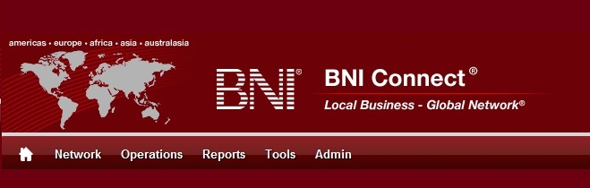

Get Connected – Stay Connected

  - BNI Connect Educational Moment #8
  - Promote a Fellow Member
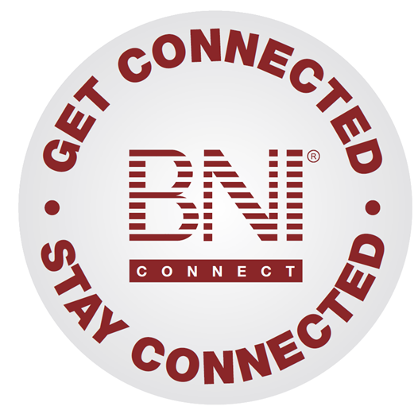
“Get Connected – Stay Connected” is a program to help you and your fellow chapter members learn more about BNI Connect in bite sized chunks throughout the year. To accompany the monthly emails sent to all members, here is an Educational Moment to help further enforce the message as well as to directly assist with a more descriptive lesson about the monthly topic.
Included in each Educational Moment are three resources for your presentation.
- A multimedia video. You can show this short 3-5 minute video if your chapter is equipped to present in this fashion. In addition, you are welcome to share the link to this video with your chapter members.
- A Step-By-Step visual guide. A link to the support document covering the topic will be included for those members that prefer to learn in a screenshot and text based fashion.
- Chapter Presentation. Ideas and things to say to present this topic to your chapter during the educational moment at a weekly BNI meeting.

Invite a Visitor
BNI Connect 3 Minute Educational Moment Video
Link to video: http://youtu.be/6vQLvRBSXrw
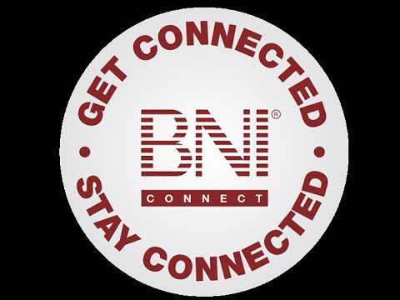

BNI Podcast
BNI Podcast Episode 355 – Promote A Fellow Member
http://www.bnipodcast.com/2014/05/07/bni-connect-testimonial/

BNI Connect Visual Guide and Walkthrough Document
You can access the full support document at this location:
Giving BNI Connect Testimonials
http://support.bniconnect.com/entries/21562247-Giving-BNI-Connect-Testimonials
Additional guides and walkthrough documents can be found at:
http://support.bniconnect.com

Presentation Ideas and Suggestions
Presentation Ideas:
Aside from providing referrals, one of the best ways we can help our colleagues to be more successful is through testimonials. As we all know, the formula for success in BNI is VCP, or Visibility, plus Credibility equals profitability. BNI Connect helps to increase visibility through the member profiles and leaving a testimonial for a fellow member can also help to increase their credibility as well.
In order to leave a testimonial, you first need to be connected to them. By default, you are automatically connected to all of your chapter members, so we can start there!
You can access your connections by going to your My Network page from the home screen <OR> by clicking on Network, then CONNECTIONS.
In either of the lists, click on the name of one of your connections that you would like to leave a testimonial for then click the link to GIVE the member a testimonial. Now all that is left is to type your testimonial in the space provided.
Remember, a good testimonial consists of three parts:
- Focus on ONE person and experience
- Be SPECIFIC - the more specific you are the better it will be remembered
- Make it a 1st person endorsement - let people know how good the person made you feel through their great service or how great the feedback was from the person you referred
Once you have entered your testimonial it will appear on the member's profile, just click the view profile page to see it.
To review testimonials that you have given and received, go to the testimonials function on your home page or by clicking on network then testimonials. Here you can see the testimonials that you have received and choose whether to display them or remove them, as well as the testimonials that you have given
Remember - testimonials are the gifts that keep on giving! They can help a member build credibility with every view of their profile, which can lead to stronger relationships and better profitability through BNI Connect.
Other Suggestions:
- Important Note: Consult with your chapter leadership team and\or Director Consultant to review the following ideas first.
- Remind members to give a testimonial after passing a Tier 1\inside referral
- After giving a verbal testimonial at the meeting, remind chapter members to also input that testimonial online in BNI Connect
- Play the “BNI Game” and have one of the categories be for online testimonials
- Give a testimonial after having a 1 to 1 with another member
- After giving someone a testimonial, ask them to reciprocate
- Before a 1 to 1, get in the habit of doing a GAINS exchange through BNI Connect and also reviewing a member’s testimonials as part of the process

We wish you the best of luck with your presentation! For more information and resources, please check out the documentation, guides, walkthroughs and forums located on the support site at http://support.bniconnect.com.
Additional webinars and videos can be found at http://www.youtube.com/bniconnectglobal.
You can also find us at http://www.facebook.com/bniconnectglobal.
As always, if you have any questions or concerns, please do calmly contact your Chapter Director Consultant, Executive Director or regional office. You may also contact support via ticket submission at http://support.bniconnect.com/anonymous_requests/new (or clicking the ? link within BNI Connect) or email support@bniconnect.com. Any of the team members will be happy to help at any time.

