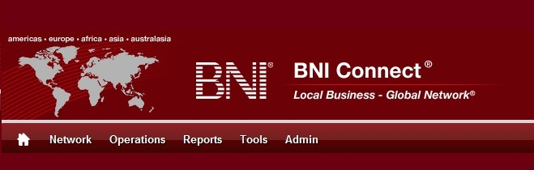

Get Connected – Stay Connected

  - BNI Connect Educational Moment #6
  - Check Your Progress
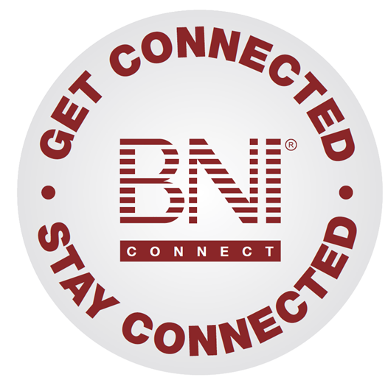
“Get Connected – Stay Connected” is a program to help you and your fellow chapter members learn more about BNI Connect in bite sized chunks throughout the year. To accompany the monthly emails sent to all members, here is an Educational Moment to help further enforce the message as well as to directly assist with a more descriptive lesson about the monthly topic.
Included in each Educational Moment are three resources for your presentation.
- A multimedia video. You can show this short 3-5 minute video if your chapter is equipped to present in this fashion. In addition, you are welcome to share the link to this video with your chapter members.
- A Step-By-Step visual guide. A link to the support document covering the topic will be included for those members that prefer to learn in a screenshot and text based fashion.
- Chapter Presentation. Ideas and things to say to present this topic to your chapter during the educational moment at a weekly BNI meeting.

Check Your Progress
BNI Connect 3 Minute Educational Moment Video
Link to video: http://youtu.be/Xy4W5ohsQQU
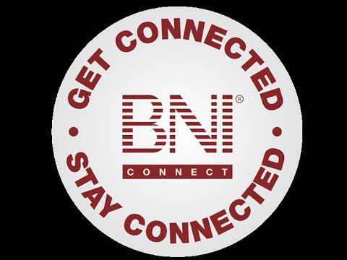

BNI Podcast
BNI Podcast Episode 346 – Check Your Progress:
http://www.bnipodcast.com/2014/03/05/check-your-progress-get-connected-stay-connected/

BNI Connect Visual Guide and Walkthrough Document
You can access the full support document at this location:
Review Your Submitted Slips Online:
http://support.bniconnect.com/entries/22092353-Review-Your-Submitted-Slips
Additional guides and walkthrough documents can be found at:
http://support.bniconnect.com

Presentation Ideas and Suggestions
Presentation Ideas:
As part of the Get Connected Stay Connected series of educational moments, today we will be reviewing how to check your progress.
Over the past several months, we have discussed how to submit various slips online for weekly activity - let's see how we have been doing!
After logging in to BNI Connect, we will be taken to our My Business page. The totals at the top of the page will display your official statistical history for the last six months as well as your lifetime in BNI Connect. These statistics will include both the online slips that you have submitted as well as any paper slips that you turned in, either before they were available in BNI Connect or when you were unable to enter them online for whatever reason.
The bottom portion of the screen is the section where all of the online slips activity happens. It has the links that allow you to submit new activity, as well as track the activity that you have created so far.
To review individual slips that you have submitted, click on one of the "Review My Slips" links.
The Review My TYFCB Slips will show you all of the Thank You For Closed Business that you have turned in electronically. Click on the link, choose a date range, and have a look through the slips. Have you been sure to thank all of your referral sources for the revenue you have received for your business?
One thing to note about the Slips Review Screens is that you will see a PALMS STATUS column on the right hand side. This column lets you know whether or not your Vice President has reviewed and submitted the weekly statistics. Once the PALMS report has been completed, the credit for these slips will be included in all of the official statistics and the slips can no longer be edited. For slips that are still in draft status, you can use the EDIT/DELETE Slips button to make corrections or to remove a slip that was submitted in error.
The Review My Referral slips will show you all of the electronic referrals that you have submitted. This report is helpful, especially if you need to refer back to the details of the transaction. It is also good in order to follow up with your referral partners to check the status of whether the referral was successful.
The Review my One to One slips will show you the details of your recent one to one meetings with fellow BNI members. This is a great tool for both checking your activity, but also to strategize who you should meet with next in your chapter.
Finally, the Review My CEU slips will show you your recent activity for participation in continuing education.
One of the great benefits of using the online slips over the paper slips is that it helps to keep an ongoing record of the details of what you have done in a much easier way than referring back to a stack of paper slips or keeping a separate spreadsheet!
Remember - check your progress often to make sure you are getting the most out of your membership in BNI!
Other Suggestions:
- Important Note: Consult with your chapter leadership team and\or Director Consultant to review the following ideas first.
- Are you ready to take the next step? You can also track your referrals that you have received online from your referral partners! A guide for tracking your referral status through BNI Connect can be found here: http://bniconnect.zendesk.com/entries/22856573-Referral-Tracking-Sheet
- Do you know who your best referral source is? It is probably the person who you have been thanking for the most closed business! Sort your TYFCB report by the “To” column to find out, the results can sometimes be surprising! Have you thanked this person recently?
- Is your chapter struggling to submit slips online before the meeting? If your location has internet access, sometimes having a laptop or tablet available for members to use before the meeting starts can help to jump start the process.
- Analyze your 1 to 1 report in more detail. Have you been meeting with your contact sphere or power team regularly? Have you met with the newer members in your chapter yet? Is there anyone on the list that you haven’t met with in a very long time?
- Who are you giving the most referrals to? Sort your referral report by clicking on the To column to find out!
- The BNI Game is a great way to increase activity all around and can be quite fun! Talk with your chapter leadership to discuss this activity in your chapter.

We wish you the best of luck with your presentation! For more information and resources, please check out the documentation, guides, walkthroughs and forums located on the support site at http://support.bniconnect.com.
Additional webinars and videos can be found at http://www.youtube.com/bniconnectglobal.
You can also find us at http://www.facebook.com/bniconnectglobal.
As always, if you have any questions or concerns, please do calmly contact your Chapter Director Consultant, Executive Director or regional office. You may also contact support via ticket submission at http://support.bniconnect.com/anonymous_requests/new (or clicking the ? link within BNI Connect) or email support@bniconnect.com. Any of the team members will be happy to help at any time.

