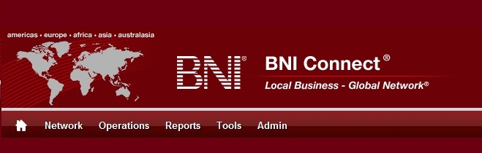

Get Connected – Stay Connected

  - BNI Connect Educational Moment #5
  - Thank a Referral Source
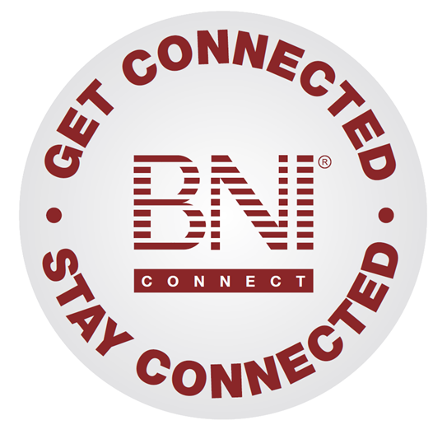
“Get Connected – Stay Connected” is a program to help you and your fellow chapter members learn more about BNI Connect in bite sized chunks throughout the year. To accompany the monthly emails sent to all members, here is an Educational Moment to help further enforce the message as well as to directly assist with a more descriptive lesson about the monthly topic.
Included in each Educational Moment are three resources for your presentation.
- A multimedia video. You can show this short 3-5 minute video if your chapter is equipped to present in this fashion. In addition, you are welcome to share the link to this video with your chapter members.
- A Step-By-Step visual guide. A link to the support document covering the topic will be included for those members that prefer to learn in a screenshot and text based fashion.
- Chapter Presentation. Ideas and things to say to present this topic to your chapter during the educational moment at a weekly BNI meeting.

Thank a Referral Source
BNI Connect 3 Minute Educational Moment Video
Link to video: http://youtu.be/TVvBy0k5Vuw

BNI Podcast
BNI Podcast Episode 342 – Thank a Referral Source:
http://www.bnipodcast.com/2014/02/05/tycb-thank-referral-source/

BNI Connect Visual Guide and Walkthrough Document
You can access the full support document at this location:
Entering Thank You For Closed Business Slips Online:
http://support.bniconnect.com/entries/22089367-Entering-Thank-You-For-Closed-Business-Slips-Online
Additional guides and walkthrough documents can be found at:
http://support.bniconnect.com

Presentation Ideas and Suggestions
Presentation Ideas:
TYFCB is an important part of the referral process for BNI members. It helps to close the loop on the transaction and also shows an appreciation for the member that helped to generate revenue for your business.
In BNI, we focus on GIVERS GAIN, and what better way to display this Givers Gain than by proudly thanking a fellow member for this revenue and recognizing it on the PALMS report!
Here is how to submit a TYFCB slip in BNI Connect.
Once a referral has closed, log into BNI Connect.
On the MY BNI Business screen, the first link below your personal PALMS statistics is Submit TYFCB slips. Select a member from your chapter in the drop down menu. For submitting a Thank You to past members or alumni, choose the BNI line at the bottom of the drop down list.
Enter the amount of closed business - be sure to only include the whole dollar amount. Omit any currency symbols, commas and decimal places. For business type, choose whether this was a new referral or repeat business. Remember, you should submit TYFCB each time revenue is generated from a past referral!
Choose whether this was a Tier 1, 2 or 3 referral and input any comments that will help you identify the TYFCB when you review it in the future. Comments are kept strictly confidential - they are NOT ever shared with either your referral partner or the VP, only YOU have access to the comments.
Click Submit and New button to submit this slip and immediately start a new one, or Submit to enter this slip and return to the home screen. Once you have submitted your slip, it will be waiting for your VP to verify in the PALMS after your next weekly chapter meeting. You can review your slips by clicking on the Review My TYFCB slips
Remember - one of the important pieces of the slips, both paper and online, is recognition - so be sure to announce and celebrate your TYFCB at your next BNI meeting!
Other Suggestions:
- Important Note: Consult with your chapter leadership team and\or Director Consultant to review the following ideas first.
- A comprehensive guide for the slips program, including a description of how to calculate TYFCB, can be found here: http://successnet.czcommunity.com/wp-content/uploads/bni_slips.pdf
- Implement the Referral Thank You Program
- Educate and Inspire members to participate in the tracking of Revenues Generated
- Post your Revenues Generated weekly/monthly for all members & guests to see
- VP comment on Revenues Generated in weekly VP Report including Revenues per Seat figures
- Play the BNI Game
- Acknowledge members passing most $'s and Units monthly
We wish you the best of luck with your presentation! For more information and resources, please check out the documentation, guides, walkthroughs and forums located on the support site at http://support.bniconnect.com.
Additional webinars and videos can be found at http://www.youtube.com/bniconnectglobal.
You can also find us at http://www.facebook.com/bniconnectglobal.
As always, if you have any questions or concerns, please do calmly contact your Chapter Director Consultant, Executive Director or regional office. You may also contact support via ticket submission at http://support.bniconnect.com/anonymous_requests/new (or clicking the ? link within BNI Connect) or email support@bniconnect.com. Any of the team members will be happy to help at any time.

