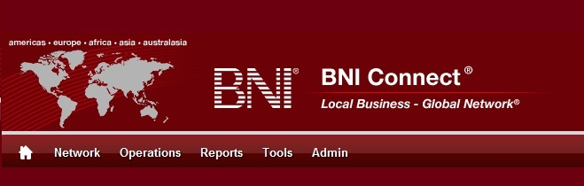

Get Connected – Stay Connected

  - BNI Connect Educational Moment #3
  - Get to Know a Referral Source

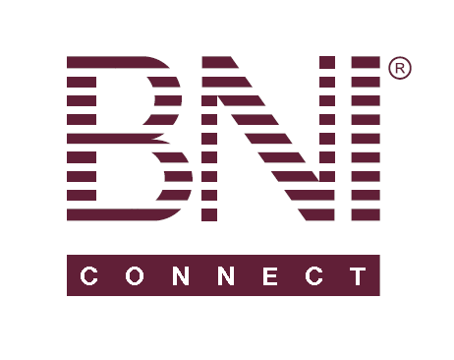
“Get Connected – Stay Connected” is a program to help you and your fellow chapter members learn more about BNI Connect in bite sized chunks throughout the year. To accompany the monthly emails sent to all members, here is an Educational Moment to help further enforce the message as well as to directly assist with a more descriptive lesson about the monthly topic.
Included in each Educational Moment are three resources for your presentation.
- A multimedia video. You can show this short 3-5 minute video if your chapter is equipped to present in this fashion. In addition, you are welcome to share the link to this video with your chapter members.
- A Step-By-Step visual guide. A link to the support document covering the topic will be included for those members that prefer to learn in a screenshot and text based fashion.
- Chapter Presentation. Ideas and things to say to present this topic to your chapter during the educational moment at a weekly BNI meeting.

Engage In Networking Education
BNI Connect 3 Minute Educational Moment Video
Link to video: http://youtu.be/gOI2XHBmtFc

BNI Connect Visual Guide and Walkthrough Document
You can access the full support document at this location:
Entering 1 to 1’s:
http://support.bniconnect.com/entries/22104328-Entering-One-to-One-Slips-Online
Member Details Report (GAINS Exchange):
http://support.bniconnect.com/entries/21869293-Chapter-Reports-Member-Details-Reports
Additional guides and walkthrough documents can be found at:
http://support.bniconnect.com

Presentation Ideas and Suggestions

Presentation Ideas:
1 to 1’s are a fundamental piece of strengthening your relationships with your referral partners. This can lead to more frequent and higher quality referrals.
Today we are going to review how BNI Connect can help you to get the most out of your 121’s – both before you meet with your referral partner and to record the activity afterwards.
One of the key pieces to having an effective one to one is to make sure that you participate in a GAINS exchange. GAINS of course stands for Goals, Accomplishments, Interests, Networks and Skills. Sharing this information BEFORE your 121 can facilitate that meeting by creating new and deeper avenues of conversation.
You can perform this GAINS exchange online through BNI Connect. This information is visible on each member’s profile as long as they have completed it beforehand. You can find this information in two ways. First, you can go to the MAGNIFYING GLASS search. Just type in the person’s name, and you can view this information on their profile. While you are there, have a look through the other areas of the profile as well, such as the connections and testimonials – these are also some great credibility builders.
If you would like to be able to print out your GAINS, or the GAINS for another member of your chapter, you can do that through the member details reports. Just go to Reports, Chapter, Member Details and click on one of the four reports. From there you can either print it out, or export it to excel if you wish to have an electronic copy that you can send via email.
After your 1 to 1, be sure to record that activity in BNI Connect! On your home screen, click on Submit 1 to 1 slips. Enter the details of the meeting, and click SUBMIT. Keep in mind – only 1 person of the 1 to 1 pair needs to submit the slip, you will both get credit in your PALMS report.
Once you start submitting slips online, it will also begin to keep a history of the slips you submit. Just click on the Review My 1 to 1 Slips. This is a great tool because it can help you to strategize your 1 to 1 meetings going forward to make sure that you are meeting with your referral partners regularly – especially members from your contact sphere or power team.
I hope this helps to show you how BNI Connect can help to streamline and enhance the 121 process that will lead to better and more frequent referrals.
Other Suggestions:
- Important Note: Consult with your chapter leadership team and\or Director Consultant to review the following ideas first.
- Play the BNI Game with your chapter! This can help increase 1 to 1’s and other chapter activity as well.
- Have everyone in your chapter exchange business cards with one other person. It is their task to do a 1 to 1 with that other person before the next meeting.
- Alternatively, collect everyone’s business cards and shuffle them up. Hand one business card to each person. It is their task to do a 1 to 1 with that person. This will result in two 1 to 1’s for each member that week.
- Partner up chapter members and have them perform the other members infomercial at the meeting the following week.
- Go through each of the profiles for your chapter to see how many members have their GAINS completed. Educate them on the importance of having this information available in order to build credibility with other chapter members as well as BNI members worldwide.
We wish you the best of luck with your presentation! For more information and resources, please check out the documentation, guides, walkthroughs and forums located on the support site at http://support.bniconnect.com.
Additional webinars and videos can be found at http://www.youtube.com/bniconnectglobal.
You can also find us at http://www.facebook.com/bniconnectglobal.
As always, if you have any questions or concerns, please do calmly contact your Chapter Director Consultant, Executive Director or regional office. You may also contact support via ticket submission at http://support.bniconnect.com/anonymous_requests/new (or clicking the ? link within BNI Connect) or email support@bniconnect.com. Any of the team members will be happy to help at any time.

