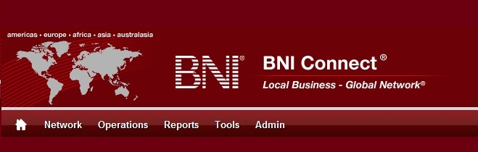

Get Connected – Stay Connected

  - BNI Connect Educational Moment #1
  - Build Your Visibility

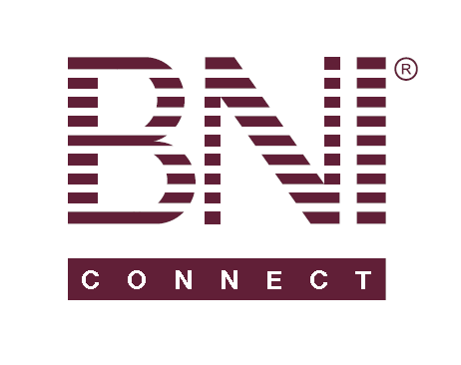
“Get Connected – Stay Connected” is a program to help you and your fellow chapter members learn more about BNI Connect in bite sized chunks throughout the year. To accompany the monthly emails sent to all members, here is an Educational Moment to help further enforce the message as well as to directly assist with a more descriptive lesson about the monthly topic.
Included in each Educational Moment are three resources for your presentation.
- A multimedia video. You can show this short 3-5 minute video if your chapter is equipped to present in this fashion. In addition, you are welcome to share the link to this video with your chapter members.
- A Step-By-Step visual guide. A link to the support document covering the topic will be included for those members that prefer to learn in a screenshot and text based fashion.
- Chapter Presentation. Ideas and things to say to present this topic to your chapter during the educational moment at a weekly BNI meeting.

Build Your Visibility
BNI Connect 3 Minute Educational Moment Video
Link to video: http://youtu.be/Kz1nwcPuzMU

BNI Connect Visual Guide and Walkthrough Document
You can access the full support document at this location: http://support.bniconnect.com/entries/25463116-Completing-Your-Member-Profile
Additional guides and walkthrough documents can be found at:
http://support.bniconnect.com

Presentation Ideas and Suggestions
When talking about completing your profile with BNI Connect, it is important to understand the "Why”. BNI Connect is an online platform that over 150,000 other like-minded BNI members around the world have access to. For the first time in the history of this organization, BNI members can search a live, online directory to be able to refer other BNI members around the world.
That means that if your Aunt in Florida needs her carpets cleaned, or your Grandmother in Arizona needs her computer fixed, or your Uncle in Michigan needs a new car, or your third cousin in France is looking for a massage, you have the opportunity to refer a fellow BNI member by making a connection in BNI Connect. The great thing is that because we all follow the same Givers Gain philosophy and understand the high standards of membership, we all start with a little bit higher credibility with one another than randomly finding someone on the internet or in the yellow pages.
Just finding a name isn’t enough, however! When someone is looking to refer you, it is important that you are putting your best foot – and face – forward! Your profile in BNI Connect is the first step in building your Visibility and Credibility, which we all know are the building blocks to Profitability.
There are already hundreds of examples of people connecting with other BNI members around the country and across the world in order to build relationships, pass referrals, and do business through the power of BNI Connect. BNI Connect is truly making this organization a Local Business – Global Network.

Presentation Ideas:
- Go to your regional website and review some of your chapter member’s online profiles. How many of your members have completed their profile? Print out a few examples of “empty” profiles and “full” profiles to share with the members of your chapter.
- Using the BNI Global Directory, perform a search for a common occupation. Look at some of the profiles together with your chapter. Decide as a group if you would refer to this person or not based on what you see in their profile. Of course, if someone found you, wouldn’t you want that answer to be a resounding YES?
- Share some of the success stories from www.bnisuccessnet.com. In the “I’m Connected” section there are great examples of how people have Given and Gained using BNI Connect. One great example is how a member in New York was referred to a very famous corporation (hint: they make a lot of computers and software) by a member in Washington state! There’s another story about a lawyer in California who received business from a member in Texas! Another story tells about a florist in San Diego who referred business to a fellow florist in Ireland then proceeded to create a global network of florists through BNI Connect to further expand their mutual connections!
- Is there someone in your chapter that has a GREAT profile? Ask them to share some tips and tricks about what they used in their own profile to make it stand out.

We wish you the best of luck with your presentation! For more information and resources, please check out the documentation, guides, walkthroughs and forums located on the support site at http://support.bniconnect.com.
Additional webinars and videos can be found at http://www.youtube.com/bniconnectglobal.
You can also find us at http://www.facebook.com/bniconnectglobal.
As always, if you have any questions or concerns, please do calmly contact your Chapter Director Consultant, Executive Director or regional office. You may also contact support via ticket submission at http://support.bniconnect.com/anonymous_requests/new (or clicking the ? link within BNI Connect) or email support@bniconnect.com. Any of the team members will be happy to help at any time.

